Instruction manual for cryogenic vessels

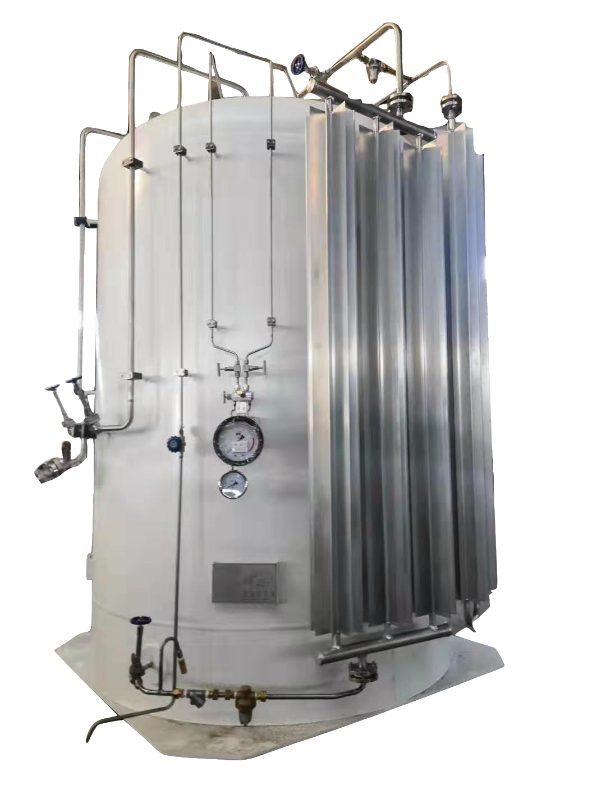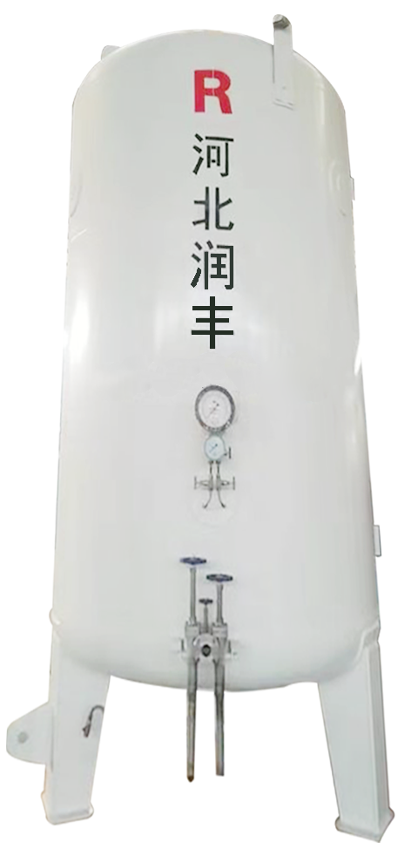

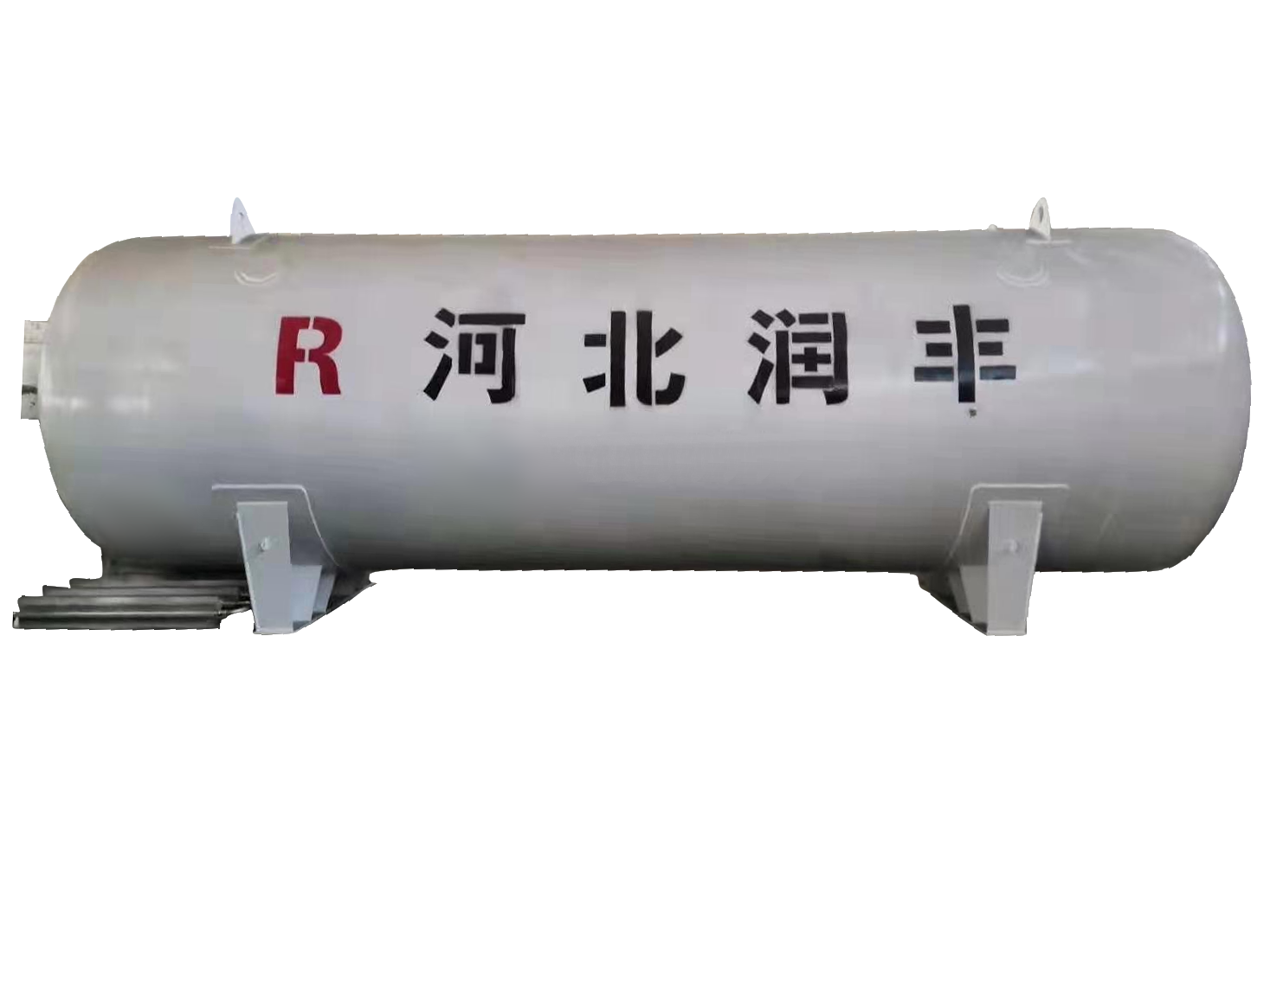

Hebei Runfeng Cryogenic Equipment Co., Ltd

catalog
- preface………………………………………………………………Page 2
- safety………………………………………………………………Page 3
3.Transportation,loading,unloading and acceptance…………………Page 6
4.Product structure and operation……………………………………Page 7
5. maintenance………………………………………………………Page 11
Annex: flow chart

Statement: the attached table and the text are of equal importance. Please read them together

Part I Preface
- Overview
This manual is applicable to all fixed cryogenic containers (hereinafter referred to as storage tanks) provided by Hebei Runfeng cryogenic equipment Co., Ltd. this manual includes information on safe operation and treatment of liquid nitrogen, liquid argon, liquid oxygen, liquefied natural gas (LNG), liquid carbon dioxide (CO2), etc. all personnel operating the equipment must thoroughly read and understand the contents of this manual, If you have any questions about product operation, please contact Hebei Runfeng customer service department. the address is:
No.1 Zhenggang Road, Xicheng Industrial Zone, Raoyang County, Hebei Province
Hebei Runfeng cryogenic equipment Co., Ltd
Postal Code:053900
Telephone:0318-5708000
The purpose of this manual is to provide the user with all necessary information related to the installation, operation and maintenance of the tank.
See Part III for safety regulations on tank operation and handling and low temperature medium transportation.
- Note: for the products of Hebei Runfeng company, customers change the relevant accessories on the equipment without the consent of Hebei Runfeng company. In case of relevant technical or safety problems, the company will not assume any responsibility. The pressure gauge and safety accessories of our products must be used within the validity period of calibration.
- terminology
The terms of safety precautions in this manual are as follows:
Warning: It means that under a certain condition, it can cause personal injury or death.
Note: It means that the equipment or parts will be damaged under certain conditions.
Note: it indicates that the contents mentioned are important and need to be emphasized or repeated.
Note: This manual is copyrighted by Hebei Runfeng Cryogenic Equipment Co., Ltd.
This manual is our general product manuals, as you have special configuration requirements, there may not exactly correspond to the place;Our company reserves the right and responsibility for continuous improvement and optimization of the product. If the improvement does not affect the safe use of the product, the manual will not be revised separately.

Part Two Security
- prompt
The storage tank is composed of carbon steel or stainless steel shell and the pressure vessel placed in it. The interlayer is multi-layer winding insulation and maintains high vacuum state. According to the actual operation under the design pressure, the safety accessories (bursting disc and compound safety valve) can protect the product in case of excess pressure. Its specification and model are calculated according to GB 150 and the code for solid pressure Yes. This product is designed and manufactured according to the safety, reliable operation and durability (it can operate without faults for many years). During operation, the correct safety and operation regulations should be strictly observed. We suggest that our customers emphasize safety and safe operation regulations to their employees and users. It is very important for each operator to carefully read all the "warnings" and "precautions" listed in this safety chapter and manual. It is recommended to review these safety points regularly.

Warning:
The storage tank contains a cryogenic or low-temperature medium, and direct contact with personnel can cause cold burns similar to burns. The operator must protect the eyes and skin that are easy to contact with liquid or frozen gas, such as wearing protective goggles or face shields, and antifreeze Gloves etc. If you accidentally come into contact with deep cold or low temperature, immediately rinse or soak the contacted parts with warm water (41-46°C) and seek medical attention in time.
Liquefied natural gas (LNG) is a flammable and explosive medium. The use site should be managed in accordance with gas regulations, with gas alarm and cut-off devices, the electrical unit used should be explosion-proof electrical, and explosion-proof tools should be used for operation and maintenance. In addition to the danger of combustion and explosion, there is also insufficient oxygen when a large amount of leakage occurs. Protective measures should be taken when personnel enter and troubleshoot.
Oxygen is a strong combustion-supporting agent, which can intensify combustion or even cause an explosion in an oxygen-rich environment. No combustibles are allowed around the equipment containing liquid oxygen (oxygen). All parts in contact with liquid oxygen (oxygen) should be treated with no oil and confirmed Its compatibility with oxygen. Lack of oxygen environment can cause suffocation, could result in serious injury or even death.
Nitrogen, argon and CO2 are non-combustible gas, will reduce the concentration of oxygen in the environment leakage, personnel need to be protected.
Before disassembling any part or unscrewing the joint, first observe the location of the part, whether it must be emptied of liquid, or only need to use a safe way to release the pressure of volatile gas. At this time, the external valves and joints will become very cold, and should be protected during operation to prevent internal pressure from causing personal injury.
attention:
Before the storage tank is put into use, the installation notification and registration certificate shall be handled according to the management regulations for the use of special equipment.
Storage tanks are only allowed to be hoisted, transported or moved under no load, and transported or moved with liquid (gas) is strictly prohibited.
Storage tank products are allowed to contain only one medium. For those marked with oxygen, It should be emptied before replacement and refilled after replacement. Mixed packaging is strictly prohibited.
Overfilling of storage tank products is strictly prohibited, LNG filling factor is 0.9, and other media is 0.95.
The vacuum port VP, the detection vacuum port VR, and the explosion-proof port provided in the storage tank are protective devices, and collision and disassembly are strictly prohibited.
The user of the storage tank shall establish a technical file card for each product, and track and record the repair status of valves and instruments; a feasible emergency plan must be formulated in accordance with the safe use rules for cryogenic liquid storage and transportation equipment and this instruction manual, and shall be submitted to the local fire safety authority for approval、filing.
- Safety Manual
The product must always meet the requirements of various predicted environmental conditions. The purpose of this safety manual is to remind that safety regulations must be strictly observed whenever an accident occurs due to damage to the container or its safety device. The same applies if the integrity or function of the container is suspected at any time.
Strictly abide by the regulations. Once the container is damaged or suspected to be defective, the liquid in the container should be drained out as soon as possible. Under no circumstances should liquid be allowed to remain in the damaged container. Furthermore, damaged or suspicious containers should not be refilled until repaired and inspected.
Need to comply with various accidents including but not limited to: accidents during transportation, immersion in water, exposure to excessive heat or fire, and severe weather conditions (earthquakes, typhoons, etc.),Whenever the container is suspected of being defective or actually damaged, the safety regulations must be strictly followed.
If it is known or suspected that the vessel has a vacuum problem (even if the above mentioned situation does not occur), the vessel shall be suspended from service and the sandwich vacuum test or static evaporation rate test shall be carried out,After confirming that there is no problem, put it into use. If there is any problem, you should contact Hebei Runfeng for disposal.
- Insufficient oxygen
The normal content of oxygen in the air is about 21%. Whether it is due to combustion or the entry of other gases, the reduction of the oxygen content in the air is potentially hazardous. The operator must take necessary protective measures.
If the oxygen content in the air drops to 15-16%, the burning of ordinary combustible substances (including those generally used as fuel for heating or lighting) will be extinguished. The oxygen content is slightly lower than this concentration, and individuals cannot make a clear judgment on the condition of the air they breathe, because symptoms such as drowsiness, tiredness, listlessness, loss of cooperation, misjudgment, and confusion may be caused by a kind of "abnormal excitement" The state of "" is covered up, making the victim mistakenly believed to be in a safe and good state. Being in the air with an oxygen content of 12% or lower will cause the personnel to coma immediately. Because the coma suddenly occurs, the operator is basically unable to save himself.
Personnel working in an oxygen-deficient environment must form an assistance group, and both operators and assistance personnel must be equipped with portable breathing equipment.
- Oxygen compatibility
If replacing parts, only use parts that are compatible with oxygen and have been degreased and cleaned under working temperature and pressure conditions.Do not use regulator, connector or hose that have been used in compressed air environment on "ansuda".Only oxygen compatible sealant and Teflon tape can be used on threaded joints, and Teflon tape can only be used on aluminum threaded joints.All new pipe joints must be leak tested with a leak test agent compatible with oxygen. For degreasing, use a compatible solvent.
- natural gas
Please strictly abide by the relevant safety precautions and operating procedures in this manual. All operators who come into contact with LNG must be familiar with LNG-related laws and regulations, and master the physical characteristics of LNG, the use of safety facilities and safety precautions.
The natural gas discharged at overpressure must be discharged in a centralized manner.Through the flame arrestor,The natural gas cannot be vented directly.
Natural gas is a flammable gas. Therefore, smoking, open flames and the use of non-explosion-proof electrical equipment are prohibited in the installation area of LNG storage, transportation and production, and lightning protection and anti-static facilities should be provided.Operation, maintenance should be used with explosion-proof tool does not produce sparks, in order to ensure safety.
LNG storage tank site should be configured to use fire-fighting equipment and facilities, such as dry powder fire extinguishers, carbon dioxide fire extinguishers, fire extinguisher or water halide in accordance with engineering design and fire authorities requirements.After the fire, the air source should be cut off quickly before the fire can be extinguished.
- carbon dioxide
Liquid carbon dioxide is a high-pressure liquefied gas, so it is necessary to avoid the formation of dry ice state when the internal pressure and temperature are too low to cause damage to the equipment.
Part III transportation, loading, unloading and acceptance
- Transport loading and unloading
Note: the storage tank can only be hoisted and transported in the empty tank state, and the lifting lug can only be used for equipment transportation and installation.
The lifting lug or outrigger of the storage tank shall be tied with the anchor chain of suitable specification, and the tank shall be tied to the trailer plate so that the tank can not slide or roll in any direction.
Under no circumstances shall the anchor chain, cable or other binding device directly contact the tank shell and damage the finish coat. Corrugated cardboard or similar material shall be used to protect the place where it may contact the tank.
All pressure safety accessories and nozzle ends must be fully protected with pipe caps or pipe tape to prevent road wear or pollution. The storage tank should be filled with nitrogen for storage during transportation.
For vertical storage tanks of less than 5 cubic meters, one hook crane or crane can be used; for storage tanks of 5 cubic meters and above, it is recommended to use two crane cranes or cranes. If necessary, use two cranes or cranes. The lifting position and load are required Determined by crane workers; horizontal storage tanks should be cranes or cranes selected according to the lifting position and load.
The hoisting of vertical storage tank is as follows:

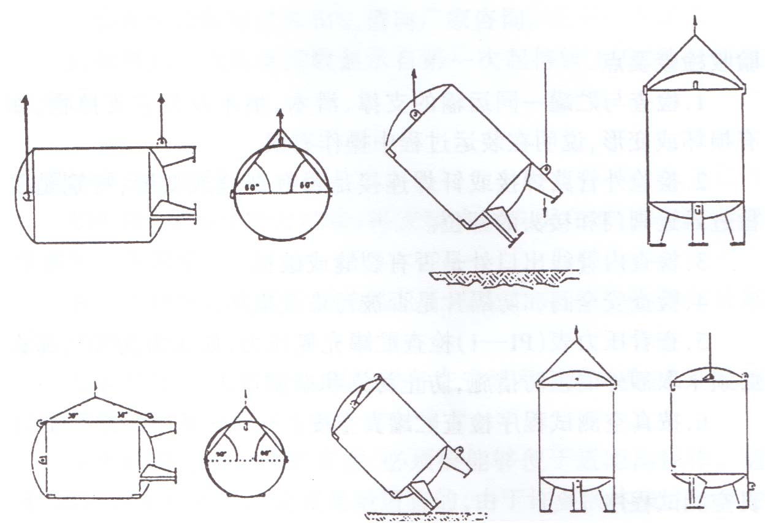
- acceptance
When receiving the goods, the following steps should be checked and accepted:
Whether the appearance of the product is collided, deformed or scratched;
Whether the valve accessories are twisted or damaged due to collisions or bumps;
Whether the nitrogen seal inside the storage tank is intact, the general pressure is about 0.05MPa;
Whether the vacuum port of the storage tank, the vacuum port and the explosion-proof device of the shell are intact;
Whether the surface paint and marking of the storage tank are in good condition.

Part IV product structure and operation
- product structure
The equipment is designed, manufactured, inspected and accepted according to GB / t150 pressure vessel and GB / T18442 fixed vacuum insulated cryogenic pressure vessel, and is supervised by TSG 21 Safety Technology Supervision Regulation for stationary pressure vessel.
The tank is equipped with top and bottom liquid inlet pipelines, which can realize pressure difference and low temperature liquid pump unloading and filling;
The liquid outlet of the storage tank can supply gas directly or enter the cryogenic pump for external gas supply;
The storage tank is equipped with gas-phase pipelines, which can realize gas discharge, safe release, pressurization and gas return after pumping;
The storage tank is equipped with an overflow pipeline to avoid overfilling when unloading and filling;
The storage tank is equipped with double safety valves (or rupture discs) to discharge when overpressure to protect the safety of the inner container;
The storage tank is equipped with a pressure gauge to display the internal pressure in real time, which should be checked regularly according to regulations;
The storage tank is equipped with a liquid level meter to display the internal medium stock, which is used for reference and not for measurement;
The tank is equipped with vacuumizing and measuring vacuum pipelines to ensure the insulation performance of interlayer;
The tank is equipped with shell explosion-proof device to discharge gas in case of leakage of inner container to avoid serious damage and danger;
The interlayer of storage tank is high vacuum multi-layer winding insulation, which has small volume, good insulation effect.
Note: the parameters of safety valve shall not be changed at will and shall be calibrated regularly, otherwise it will cause safety accidents.
- Operation introduction
2.1 Purging and pre-cooling
The new tank, the storage tank which has been out of service for a long time or reused after maintenance needs to be purged and precooled, and the medium used is the same as the filling medium.
Note：The maximum purge pressure does not exceed 50% of the maximum operating pressure of the storage tank, and a positive pressure of at least 0.03Mpa must be maintained in the storage tank to prevent the pollutants in the atmosphere from being sucked back into the storage tank.
2.1.1 Check whether the pipelines and valves are well connected, whether the joints are loose, whether the safety valve is in working condition, whether the pressure gauge and level gauge are correct; the system instrument valve has been set in use before leaving the factory, but the user has to use it before It should still be checked that all valves are in the correct state.
Note：It is strictly forbidden to open only the gas phase valve or only the liquid phase valve when the balance valve is closed, otherwise the instrument will be damaged!
2.1.2 Connect the tank truck pipeline to the upper and lower liquid inlet pipelines of the storage tank firmly, and install an electrostatic grounding device.
2.1.3 First, the gas (in the gas phase instead of the liquid phase) in the tanker enters the storage tank through the liquid inlet line at the bottom of the storage tank. After reaching the purge pressure, the gas valve, the liquid outlet valve, the overflow valve, the gas discharge valve, etc. are sequentially opened; open Balance valve of the level gauge, loosen the pipe joint of the level gauge, and vent outward; check whether the exhaust of each pipeline is smooth and whether it contains moisture or impurities. After the purging is qualified, restore the level gauge pipeline and close the drain valve and overflow valve .
Note: If the capacitive liquid level gauge is assembled, the liquid level gauge pipeline does not need to be operated; if the gas has a purity requirement, it should be checked that the exhaust gas purity reaches the standard before stopping the purge and replacement.
2.1.4 After the gas pipeline of the storage tank continues to discharge until the pipeline is frosted, the small flow of the tank truck can be switched to fill the liquid through the liquid inlet pipeline on the top of the storage tank, At the same time the gas-phase pipeline of the storage tank continues to discharge. Always pay attention to observe the pressure and pressure rise rate in the storage tank, and control the liquid inlet speed and pressure of the storage tank by adjusting the opening of the top inlet valve.
Note: When the pressure in the storage tank reaches 80% of the working pressure, the liquid supply should be suspended and the liquid supply will continue after the pressure in the storage tank drops.
2.1.5 When the pressure in the storage tank begins to drop during the liquid inlet process, the liquid inlet speed can be gradually increased, and the opening of the exhaust valve can be reduced at the same time, until the exhaust valve is closed and the pre-cooling is completed, the liquid can be quickly introduced.
Attention: since the valve, instrument joint and flange of the storage tank are assembled and fastened at normal temperature, the cold contraction may cause leakage at the connection during precooling. If leakage is found, it should be tightened in time, and if necessary, the filling can be suspended and the liquid and gas in the pipeline should be drained for post-treatment. During the precooling process, attention should be paid to observe whether the product body is abnormal, whether there is local sweating and frosting In case of any abnormality, the precooling shall be stopped in time.
2.2 Filling
The first filling can be carried out continuously after the pre-cooling is completed, and the refilling is carried out according to the following procedures:
2.2.1 Make sure that the medium contained in the tank of the tank car is exactly the medium to be transported.
2.2.2 Check all the pipes and tank connector is securely connected to the valve is correct, to confirm manometer valve, safety valve, gauge is working, the other valve is in a closed state.
2.2.3 Connect the pipeline of the tank truck with the corresponding pipeline of the storage tank with an infusion hose, and install an electrostatic grounding device to purge the inside of the filled metal hose.
2.2.4 The filling can be carried out separately from the bottom and the top, or at the same time. During the filling process, the pressure in the storage tank must not be overpressure, and the vaporized gas should be discharged through the exhaust valve.
2.2.5 When filling with differential pressure, the pressure in the tanker should be kept higher than the pressure in the storage tank by more than 0.2MPa, and cryogenic pumps can also be used to fill the storage tank, and top filling is preferred to prevent the pressure in the storage tank from increasing.
2.2.6 Overfilling of storage tanks is strictly prohibited, and the filling factor is not more than 95% (90% for LNG storage tanks). When the design liquid level is about to be reached, the overflow valve can be opened to check whether the filling is in place. Stop immediately when liquid flows out Refill.
2.2.7 After the liquid inlet is completed, the gas pressure in the tank truck must be used to blow the liquid remaining in the liquid inlet pipe on the top of the storage tank into the storage tank, and then close the liquid inlet valve of the storage tank,The residual liquid and gas in the filling hose can be drained by the small valve on the combined filling valve or the pipeline vent valve equipped with the tank car. Then remove the unloading hose.
2.3 Gas or liquid supply
2.3.1 When the gas is supplied, the liquid outlet valve is opened, and the liquid is vaporized by the air-temperature vaporizer and then enters the pressure reducing device, and then is transported to the gas point. The pressure in the storage tank should be higher than the gas pressure, and the pressure-increasing pressure regulator C-1 and the pressure-reducing pressure regulator C-2 can be adjusted to control the pressure in the storage tank to meet the requirements use.
2.3.2 When the liquid is supplied, the liquid outlet valve is opened, and the liquid is boosted by the cryogenic pump and then enters the high-pressure vaporizer, and after the pressure is stabilized, it is transferred to the gas point or bottle filling. Keep the pressure in the tank as low as possible when supplying liquid.
2.4 Pressure reduction and safe discharge
2.4.1 When the gas consumption is too small and the liquid is stored for a long time, the pressure in the storage tank will gradually increase. It is recommended that when the pressure in the storage tank increases close to the maximum working pressure, the user should open the exhaust valve to manually depressurize.
2.4.2 Tank internal pressure continues to rise, the configuration of the storage tank safety valve open, closed after pressure relief(The sealing pressure of the safety valve is generally 90% of the set pressure); if it is frozen and cannot be automatically closed, you need to adjust the direction of the handle of the three-way ball valve to automatically close after returning to normal temperature.
2.4.3 When the safety valve fails or the opening pressure is not punctual, the pressure in the tank will rise again, and the bursting disc equipped with the storage tank will burst, which will rapidly reduce the pressure in the tank.
Note: After the bursting disc is blasted, you can only manually adjust the handle of the three-way ball valve, close the group of discharge devices, and replace the new bursting disc in time.
2.5 Precautions for operation of differential pressure level gauge and pressure gauge (no such requirement for capacitive level gauge)
Regardless of dismantling or adjusting the pressure gauge (P1) or the level gauge (L1), the balance valve must be opened first.
2.5.1 Operation sequence of level gauge (L1):
——When opening the level gauge (L1)
a、 Open the balance valve, and then open the gas-phase valve and liquid-phase valve of the level gauge in turn;
b、 Then slowly close the balance valve and the liquid level gauge (L1) starts to work.
——When closing the level gauge (L1)
a、 First, slowly open the balance valve;
b、 Then close the liquid level valve of the level gauge and the gas phase valve of the level gauge in turn, and the level gauge (L1) will stop working.
——When the liquid level gauge (L1) is calibrated to zero
a、 First, slowly open the balance valve;
b、 Then close the liquid level valve of the level gauge and the gas phase valve of the level gauge in turn, and adjust the pointer of the level gauge (L1) to zero.
2.5.2 Since the diameter of the gauge tube of the level gauge is very small, it is easy to be blocked by ice. Therefore, it is necessary to carefully check whether there is moisture in the gas and liquid phase pipes of the level gauge to ensure that the liquid level gauge (L-1) will not fail during operation.
2.6 Tank pressure control
2.6.1 The lowering pressure setting of the storage tank is controlled by the lowering pressure regulating valve C-2, and the operating pressure can be adjusted in any way without removing the parts.
a. First raise the tank pressure to the desired pressure,Loosen the rear connector of the pressure reducing regulator.
b. Turn the adjusting knob counterclockwise to slowly adjust the pressure control valve (C-2).
Note: counter-clockwise 1/2 weeks, the pressure will drop 0.15Mpa.
c. When there is gas discharged from the rear joint of the pressure reducing regulating valve, it is the set value of the pressure reducing regulating valve.
d. Repeat steps B and C as appropriate.
2.6.2 The pressurization set pressure of the tank is controlled by the pressure increasing regulating valve (C-1). Any adjustment can be made to the operating pressure without removing the parts.
Manual increase of set pressure steps:
a. Record the existing tank pressure.
b. Rotate the adjusting screw of the boost adjusting valve (C-1) clockwise.
Note: A 1/2 turn clockwise is equivalent to a pressure rise of about 0.15Mpa.
c. After the tank pressure rises and stabilizes for 30 minutes, determine the new pressure setting.
d. Repeat steps b and c as appropriate.
The steps of manually lowering the set pressure are the same as the above method, turning counterclockwise when adjusting. When reducing the set pressure, the pressure in the storage tank must first be reduced to below the set pressure.
2.6.3 The pressure in the storage tank can be reduced by exhausting the gas through the exhaust valve or releasing the safety valve.

Part V Care and Maintenance
1. matters needing attention
The valve must be opened slowly and closed slowly. The hand wheel should return half a circle after opening to the bottom. It is forbidden to use "F" wrench to operate. If the valve is found frozen, clean oil-free warm water or hot nitrogen should be used for thawing before operation.
Note: any part of cryogenic storage tank shall not be knocked by hammer or other objects, and the factory state must be maintained.
The explosion-proof cover on the top of the front end of the shell of the low-temperature tank is an automatic safety device, which is not allowed to be disassembled or skid opened.
The top and bottom filling valves, supercharger inlet valves and full measuring valves on the cryogenic storage tank are often opened and closed during normal liquid loading and unloading. Attention should be paid to their sealing performance. If there is a small amount of leakage, the sealing gasket should be replaced in time.
The gas and liquid phase valves and safety relief selection valves of the liquid level gauge are often used in the normal operation process, and the sensitivity of their switches should be checked frequently.The gas and liquid valves of the differential pressure level gauge should be closed when repairing the differential pressure level meter to avoid accidental overflow of gas and liquid;The safety relief selection valve can be closed when the safety valve is replaced or repaired. But in normal use, the valve must be opened.
The manual vent valve is a normally closed valve during normal operation. The sensitivity of the switch should also be checked frequently.When the pressure of the storage tank exceeds or approaches the maximum working pressure, the manual vent valve can be opened to reduce the pressure to ensure the safe use of the storage tank;
Warning: before the tank is maintained or replaced, the tank pressure should be lowered to a safe state. For LNG storage tanks, if hot work is required, the LNG contained in the storage tank shall be completely emptied and replaced with nitrogen, and hot work can only be carried out after safety.
- Regular inspection
In order to keep the storage tank in good working condition, the following parts of the device must be inspected regularly and applied for inspection. If the storage tank has been working in extremely hot or cold air temperature environment, the inspection cycle should be shortened.

Inspection items | cycle
Valves and fittings | Three months
Pressure gauge | 6 months (must be verified by the national metrology department)
Safety valve (YA) | 12 months according to 《固规》
External inspection of storage tank | according to 《固规》
- Vacuum integrity check
Since the storage tank is vacuum insulated, any reduction or loss of vacuum will cause abnormal rapid pressure increase in the storage tank. The operation of the device should be suspended in time, and the company should truthfully report it to the company and consult how to conduct vacuum testing and maintenance on the storage tank. If there are other abnormal conditions (such as: signs of frozen particles, frost or condensation), they should also be reported to the company in time to determine the integrity of the vacuum.
- Repair
Failure checklist
fault | Hypothetical reason | counter measures
High Pressure | Filling at non low temperature | Open the gas discharge valve to reduce the pressure and make it reach a lower pressure again.
High Pressure | The pressure gauge is faulty | Through a calibration table to determine pressure test. If the pressure gauge is faulty, replace it.
High Pressure | The vacuum is not high | See the "Vacuum Loss" fault column
The pressure cannot be maintained | Safety valve leak | Replace with a new and verified safety valve
The pressure cannot be maintained | Pipeline leak | Soapy water test and repair
The pressure cannot be maintained | Low liquid level | again fill
The pressure cannot be maintained | Frequent pressure relief | Consult our company
Vacuum loss | Interlayer explosion proof cover open or rusted | If the explosion-proof cover is impacted by external force or the inner tank or pipeline leaks, and the liquid in the tank is discharged, contact our customer service for technical support
Vacuum loss | Loss of vacuum port seal | If the vacuum port is impacted by an external force or the sealing ring fails, please contact our customer service for technical support
Vacuum loss | Serious water droplets or frost on the outer tank | Do the evaporation rate test for the vacuum of the storage tank. If it is unqualified, please contact our customer service for technical support.
The level gauge reading is unstable or error | Meter tube leakage | Soap liquid test and repair leaks
The level gauge reading is unstable or error | Pointer does not move | Light tap pointer,if this does not solve the problem, check the pointer according to the situation,And pull slightly bent pointer
The level gauge reading is unstable or error | The pointer is not adjusted to zero | See "Level Gauge Adjustment"
The level gauge reading is unstable or error | The meter is malfunctioning or damaged | replace
Safety valve leak | Dust or ice under the spool | Reinstall or replace the valve according to the situation
Safety valve leak | Incorrect valve installation | Reinstall or replace the valve according to the situation
Safety valve leak | The valve seat is damaged | Replace valve
5.1.1 It is recommended to replace damaged parts with parts permitted by our company, but if it is necessary to repair damaged parts, follow the following regulations.
If you need to disassemble the tank parts, you must number the removed parts for reinstallation. Always install the parts in the reverse order of the removal. During the disassembly process, prevent the removed parts from being damaged,If it cannot be reinstalled immediately, clean it thoroughly, put the parts in a polyethylene protective bag, clean all metal parts with a good industrial cleaning agent, and clean all rubber parts in detergent and hot water.Dry all cleaned parts with clean, low-pressure nitrogen. Before installation, ensure that all parts have been thoroughly cleaned and degreased. Cleaning can prevent the valve from freezing during operation and prevent the medium in the tank from being contaminated.
Note: When removing parts from the tank,Always remember to plug the exposed nozzle as soon as possible.
5.1.2 If a valve is suspected to be faulty, disassemble and repair it according to the following methods. If there is a leakage at the valve seal, tighten the sealing nut first. If the leakage stops, you can continue to use it.If the leakage does not stop, first empty the pipe section or the pressure in the storage tank, disassemble the valve, and check the seal; after cleaning and drying, replace the new seal and reseal the valve.
The safety valve cannot be repaired by itself. If the safety valve shows signs of leakage or failure, it needs to be replaced.Please use the sealing elements or materials recommended by the original valve manufacturer and check them to be qualified before putting them into use.
After completing the relevant maintenance such as disassembly or replacement of parts, all the removed and reinstalled valves and pipe joints should be leak tested.Do not return the tank to operation until all leaks are repaired and the tank is retested.

Annex: a flowchart (flowchart general reference only, specific operations, see the product comes flowchart)

kuai yi leng Oxygen nitrogen argon
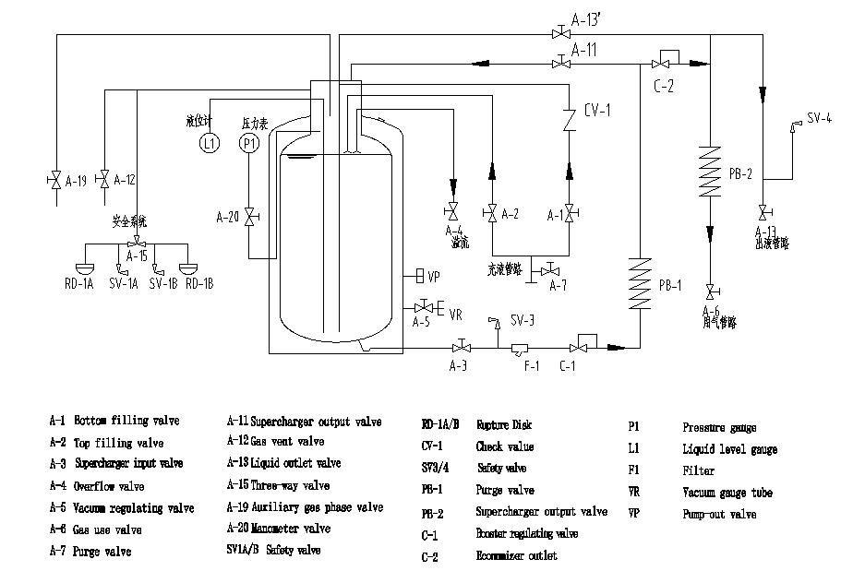

Kuai yi leng natural gas

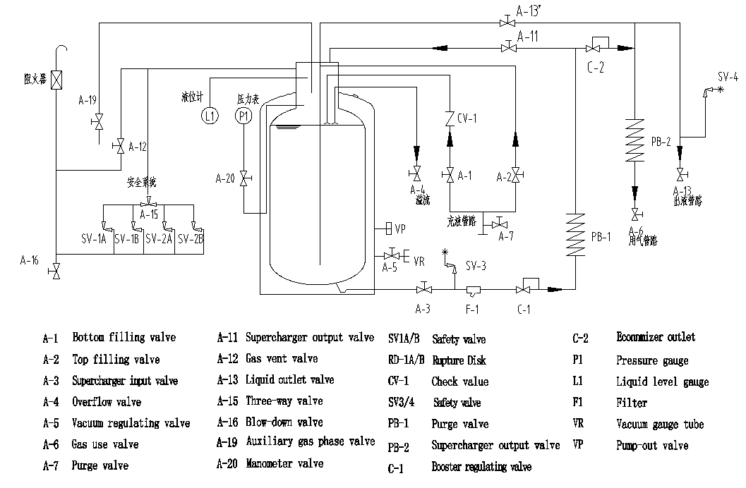
Kuai yi leng carbon dioxide
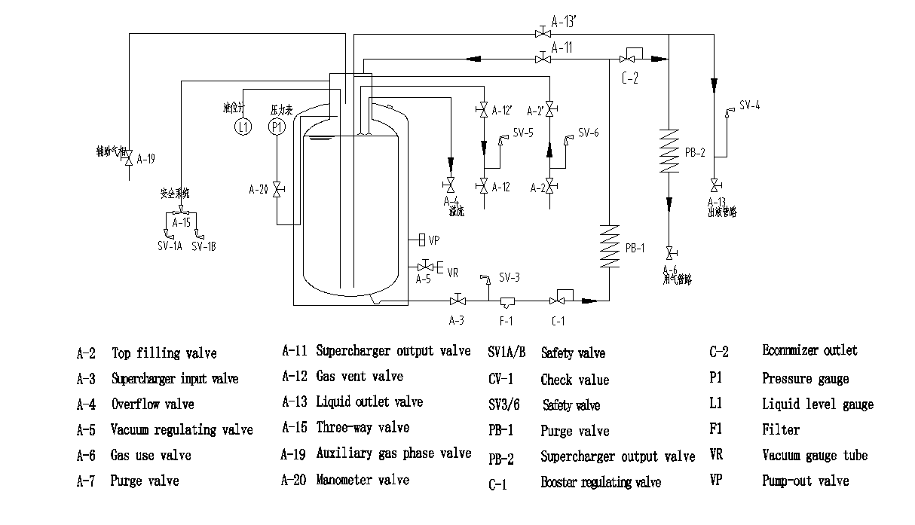

Horizontal Oxygen nitrogen argon

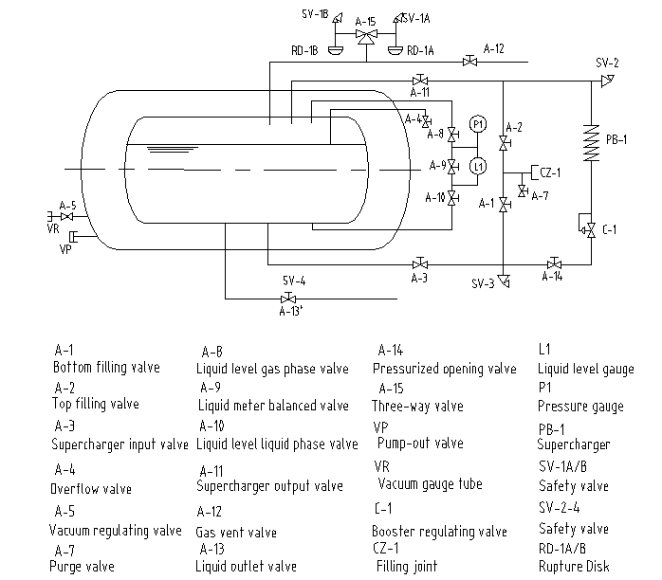

Horizontal natural gas
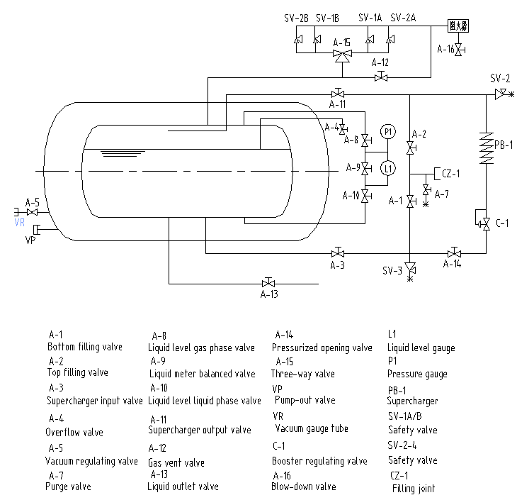

Horizontal carbon dioxide
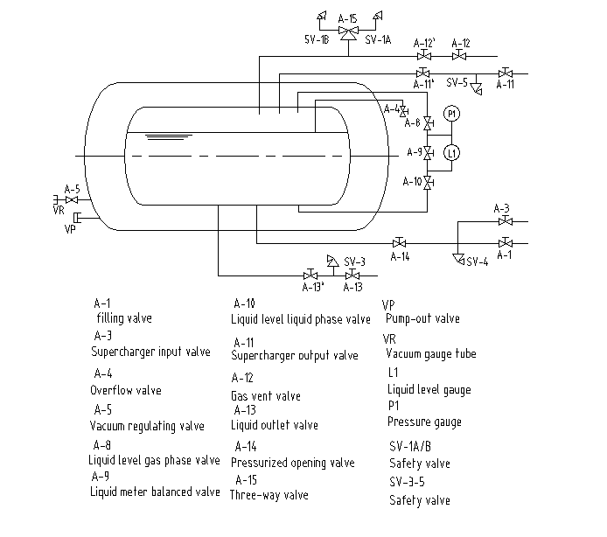
Vertical Oxygen nitrogen argon
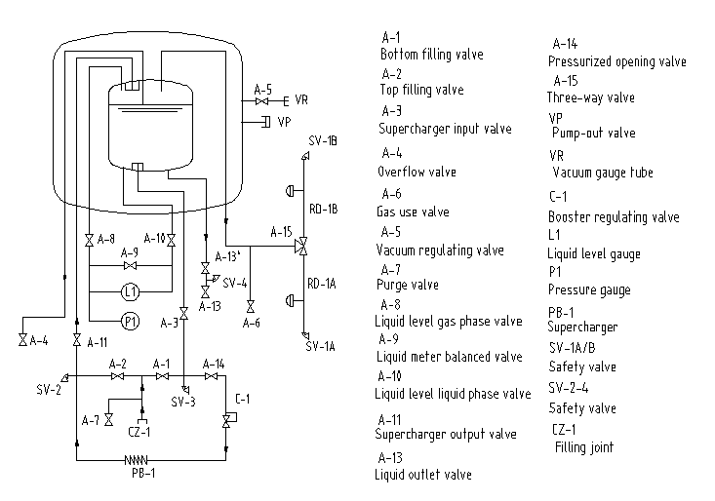

Vertical carbon dioxide
